 | Roll No.: 1814085 |  | B. Tech | 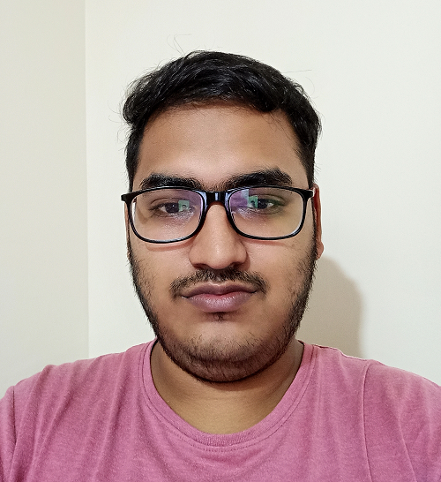
 | Name: Chirag Jhawar
Address for communication:
A 102 Manibhadra galaxy Ichalkaranji – 416115, Maharashtra

 | DOB:22/02/1999 | Mobile No: 9922913346
 | E-mail: chirag.jhawar@somaiya.edu
 | Department: Information Technology

Examination | University/Board | Institute/College | Year of Passing | YPI / CGPI / %Marks
SY | Mumbai | KJSCE | 2020 | 8.42
FY | Mumbai | KJSCE | 2019 | 8.5
HSC | Ichalkaranji | Kishor Career Point | 2018 | 86.31%
CBSE | Ichalkaranji | Mount Litera Zee School, Ichalkaranji | 2016 | 10 CGPA

Key Scholastic Achievements
Secured 373 rank in Comedk | 2018

Internships
Organization | From | To | No of Weeks
KJSCE (In House) | 7/12/2019 | 1/3/2020 | 10
Grade Stack Pvt Ltd | 11/4/2019 | 15/8//2019 | 16

Extra Courses/Certification Done
Organization | Name of course/Certification | Year | Other details / PI etc.
UC San Diego (Coursera) | Algorithms on Graphs | 2020 | 83.33%
IBM (Coursera) | Introduction to Data Science | 2020 | 85%
IBM (Coursera) | Tools for Data Science | 2020 | 83.21%
IBM (Coursera) | Data Science Methodology | 2020 | 89%
IBM (Coursera) | Python for Data Science and AI | 2020 | 94%
IBM (Coursera) | Databases and SQL for Data Science | 2020 | 91%

Extracurricular Activities
Social Activities
Organizing Group – Abhiyantriki Technical Fest (2019)
Hobbies
Watching movies, reading new tech blogs

Other Activities: Academic Projects/Presentations/Publications/Participation in Competitions
- Details of Activity | Year
Created a ticket booking system for Railways in C | 2019
Created a simple bank application using JAVA Swing and My Sql as a database | 2020
Took part in Smart India Hackathon | 2020
Done data scraping for social media sites such as Twitter in Python | 2020

Technical Skills
JAVA, Python, C, SQL, Machine Learning, HTML5, CSS

Competitive Programming
Hackerank – 6 stars in Problem Solving
5 star in Python
CodeChef - 3 star CodeChef Rating

